SIMPLE PET CARE & VACCINATION LOG
@CREATIVITY THINK (9483175986/7019689991)

ABSTRACT:
Simple Pet Care & Vaccination Log is a web-based system designed to help pet owners and veterinary clinics maintain organized records of pets, vaccination schedules, vet visits, and health reminders. The platform allows users to create detailed pet profiles, log vaccinations and vet visits, set reminders for upcoming doses, and view health timelines. Administrators can manage vaccine templates, verify owner accounts, monitor pet population statistics, and generate vaccination coverage reports. Developed using Django and Django REST Framework for backend operations, and React with react-table and axios for frontend interactivity, the system ensures accurate tracking, reminders, and data-driven insights for pet health management..

INTRODUCTION OF THE PROJECT:
Managing pet health and vaccination records manually is cumbersome and prone to errors. Pet owners often forget vaccination dates or vet visits, while clinics lack centralized systems to monitor pet health trends and vaccination coverage. Simple Pet Care & Vaccination Log addresses these challenges by providing a digital platform where pet profiles, health logs, and reminders are stored and monitored in real time. This ensures timely care, organized record-keeping, and better communication between pet owners and veterinary professionals..

PROJECT OBJECTIVES:

• Provide a digital system for maintaining pet profiles including name, breed, age, and photos
• Track vaccination records and vet visit logs efficiently
• Set reminders for upcoming vaccination doses and health check-ups
• Display pet health timelines and visual progress charts
• Allow downloading of pet care cards in PDF format
• Enable administrators to add and manage common vaccine templates
• Verify and manage pet owner accounts securely
• Generate analytics reports on vaccination coverage and pet demographics
• Support better planning and preventive care for pets

PROBLEM OF THE STATEMENT:
Pet owners often struggle to track vaccination schedules and vet visits, leading to missed doses or incomplete records. Veterinary clinics may lack an organized system for monitoring multiple pets and generating vaccination reports. Simple Pet Care & Vaccination Log solves these problems by providing a centralized platform for record-keeping, reminders, and analytics, ensuring pets receive timely care and clinics maintain comprehensive population statistics..

MOTIVATION OF THE PROJECT:
• To digitalize pet health records and vaccination management
• To provide automated reminders to ensure timely vaccinations
• To reduce errors and manual tracking for pet owners and clinics
• To provide analytics on pet population, age groups, and vaccination coverage
• To improve communication between pet owners and veterinary staff
• To allow easy access to pet profiles and health history
• To generate downloadable reports for personal or clinic records
• To enhance overall pet health management efficiency

BLOCK DAIGRAM OF PROJECT:

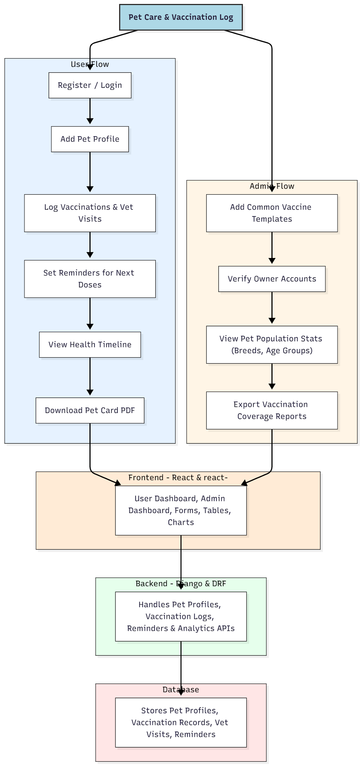

WORKING OF THE PROJECT:
Pet owners register on the portal and create detailed profiles for each pet. They log vaccination history, vet visits, and set reminders for upcoming doses. A health timeline provides visual tracking of pet care progress. Administrators add vaccine templates, verify owner accounts, monitor pet population statistics by breed and age group, and export vaccination coverage reports. The backend handles API requests, stores structured data, and triggers reminders, while the frontend provides dashboards with interactive tables and charts, ensuring a seamless user and admin experience..

SOFTWARE REQUIREMENT:
- Backend:
  - Python 3.x
  - Django
  - Django REST Framework
  - SQLite/PostgreSQL
- Frontend:
  - Node.js and npm
  - React.js
  - Axios
- Development Tools:
  - Visual Studio Code
  - Postman (for testing APIs)
  - Git/GitHub (for version control)
- Server/Deployment (Optional):
  - Gunicorn, Nginx, or Heroku/AWS for hosting

ADVANTAGES OF THE PROJECT:

• Centralized pet health and vaccination record management
• Automated reminders for vaccinations and vet visits
• Visual health timelines for easy tracking
• Downloadable pet cards in PDF for personal or clinic use
• Admin dashboard for managing vaccines and owner accounts
• Analytics on pet population and vaccination coverage
• Reduces manual errors and improves preventive care
• Enhances communication between pet owners and clinics

APPLICATIONS OF THE PROJECT:
• Pet owners for personal pet care management
• Veterinary clinics for client record management
• Animal shelters for health monitoring of multiple pets
• Pet boarding and daycare centers
• Pet vaccination awareness and compliance tracking

REFERENCES:

- Django REST Framework Documentation — Django Software Foundation. Django Documentation. Available: https://docs.djangoproject.com/
- Django REST Framework. DRF Documentation. Available: https://www.django-rest-framework.org/
- React. React Official Documentation. Available: https://reactjs.org/docs/getting-started.html
- Redux. Redux Documentation. Available: https://redux.js.org/introduction/getting-started
- PostgreSQL Global Development Group. PostgreSQL Documentation. Available: https://www.postgresql.org/docs/
- MySQL. MySQL Reference Manual. Available: https://dev.mysql.com/doc/
- Git. Git Documentation. Available: https://git-scm.com/doc
- Node.js. Node.js Documentation. Available: https://nodejs.org/en/docs/
- Axios. Axios Documentation. Available: https://axios-http.com/docs/intro
- Socket.io Documentation – https://socket.io/docs/

